DEPI

Team number : 1

Link source : [Students' Social Media Addiction](https://www.kaggle.com/datasets/adilshamim8/social-media-addiction-vs-relationships)

GitHup link: [team1depi · GitHub](https://github.com/team1depi)

Members name :

1. Mohamed Mohamed Galal Mohamed
2. Yousif Mohammed Saied Mohammed
3. Mariam Diaa Salama Haider
4. Shahd khalifa abdelmaged ibrahim
5. Shahd Yasser Hassan Ali
6. Mona Mohamed Abd Elhady Shaheen

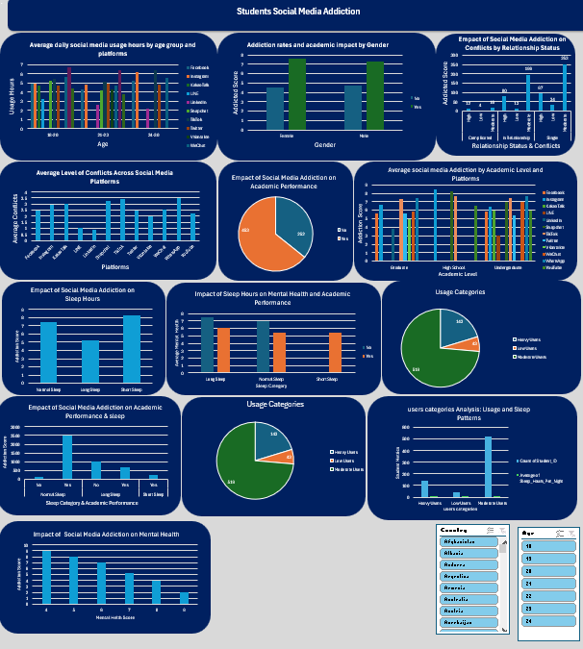

**Student social media addiction**

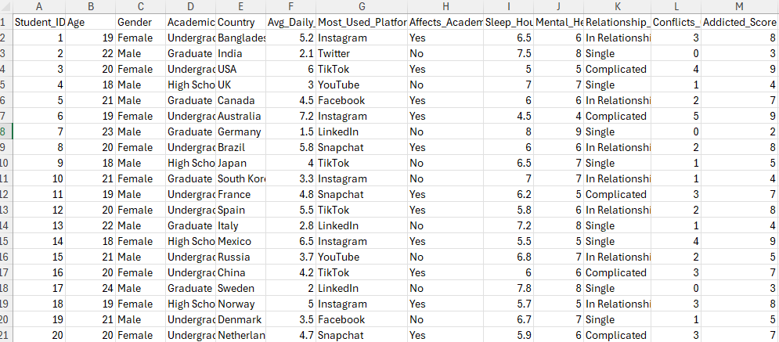

This is the first data we got it to make anylsis.

The team suggested that we add 5 columns.

1-The ages of each group of students and name is “Age Group”.

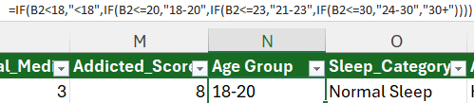

2-“The sleep category” 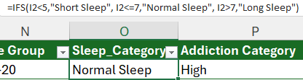

**3-“Addiction Category”**

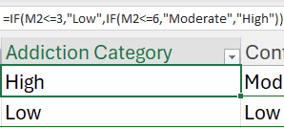

**4-“Conflict Category”**

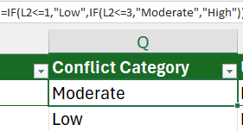

**5-“Usage Group”**

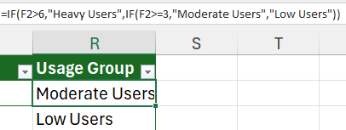

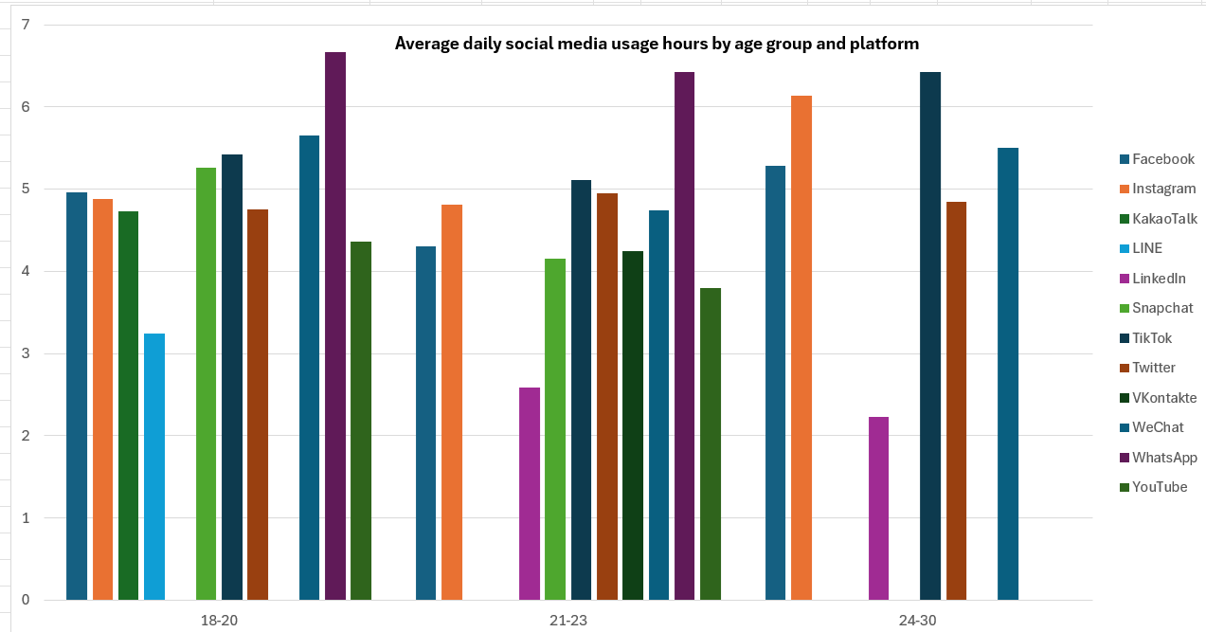1-**Average of Avg Daily Usage Hours Column Labels**.

* **Teenagers and young adults** lean more toward fast and entertaining apps (WhatsApp, TikTok, Snapchat).
* **Older young adults (24–30)** are more engaged with broader and career-related platforms (Facebook, Inst There is a gradual shift from **light/entertainment-focused apps** to **more serious andprofessional apps** as people 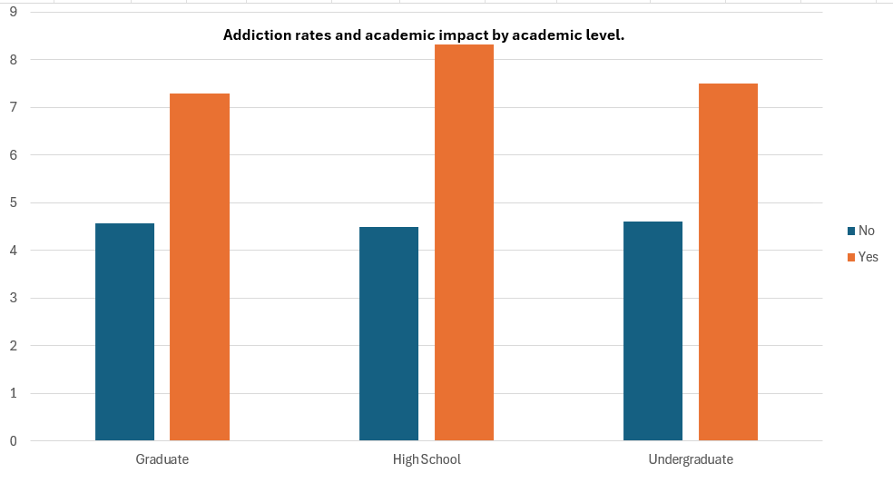

### ***Addiction Rates and Academic Impact by Academic Level***

* **High school students** are the most vulnerable to addiction and its negative academic effects.
* **Undergraduate students** are also significantly affected, though less than high school.
* **Graduates** are the least affected, likely due to greater maturity and self-control.
* Overall, addiction has a stronger impact than non-addiction in every academic level, as the "Yes" bars are consistently higher.

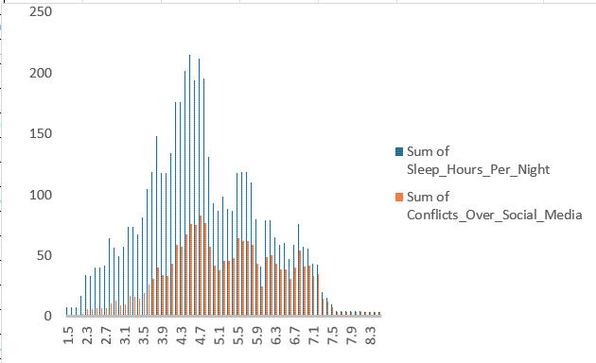**3- average daily social media usage (in hours):**

* People who sleep **fewer hours (4–5 hours)** are more likely to experience conflicts related to social media.
* **Lack of sleep is associated with increased social conflicts.**
* Those who sleep sufficiently (6+ hours) tend to have fewer conflicts.
* The chart suggests that social media may contribute to **reduced sleep** and, in turn, to **more social conflicts**.

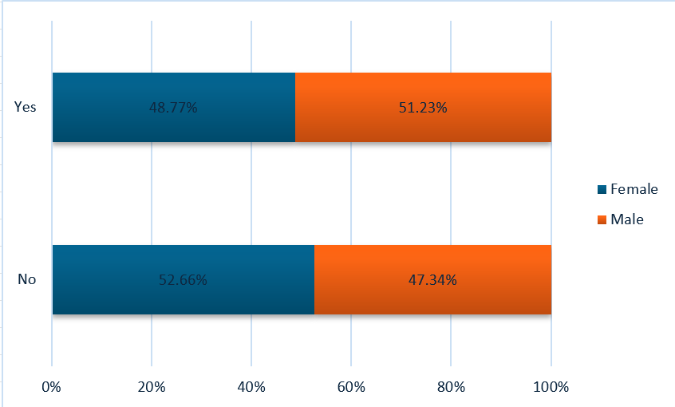4-**compare with Gender and Affects _Academic_ preformance .**

* The difference between males and females is small but noticeable:
  + **Males lean more toward “Yes.”**
  + **Females lean more toward “No.”**
* Overall, the distribution is nearly balanced, showing that opinions between genders are quite similar, with only minor differences.

5-Most used platforms

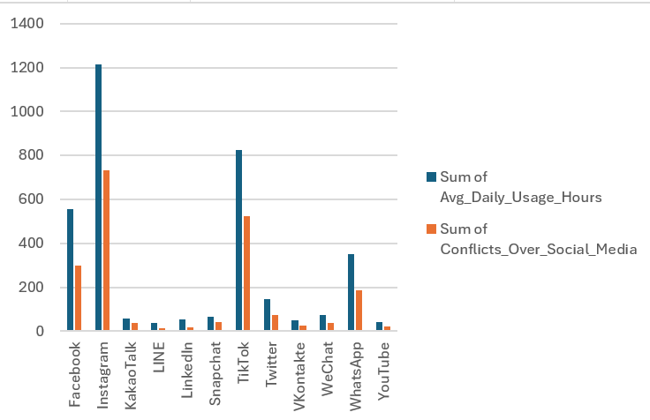

**Observations:**

* **Instagram**: Highest daily usage (≈1200 hours) and also the highest conflicts (≈700).
* **TikTok**: Second highest usage (≈820) with high conflicts as well (≈520).
* **Facebook**: Significant usage (≈560) and conflicts (≈300).
* **WhatsApp**: Moderate usage (≈400) with fewer conflicts (≈180).
* **Twitter**: Moderate usage (≈150) and moderate conflicts (≈70).
* Other platforms (LINE, LinkedIn, Snapchat, VKontakte, WeChat, YouTube): Very low in both usage and conflicts.

**. Trends:**

* The most-used platforms (**Instagram, TikTok, Facebook**) are also the ones with the highest conflicts.
* There is a clear **positive correlation** between higher usage and more conflicts.
* **WhatsApp** shows relatively high usage but lower conflicts compared to Instagram or TikTok.
* Professional or less popular platforms (e.g., LinkedIn, LINE) have minimal impact.

**6-Compare with sum addicted score and sum of conflicts over social media.**

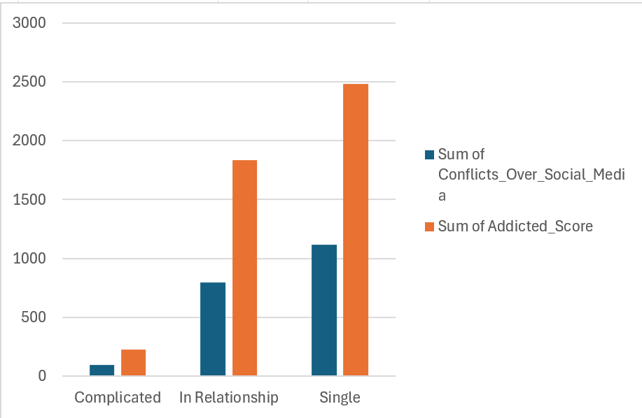

**Observations:**

* **Single individuals**: Highest addicted score (≈2500) and also the highest conflicts (≈1100+).
* **In a relationship**: High addicted score (≈1800) with considerable conflicts (≈800).
* **Complicated status**: Very low in both addiction (≈200) and conflicts (≈100).

**. Trends:**

* There is a **direct relationship**: higher addiction scores are associated with more conflicts over social media.
* **Singles** appear most vulnerable to social media addiction and related conflicts.
* **People in relationships** also show strong addiction, though slightly less than singles, and they still face many conflicts.
* **Complicated status** users are the least engaged, showing minimal addiction and conflict.

7-**Average of Addicted_Score by Academic Level and Platform**

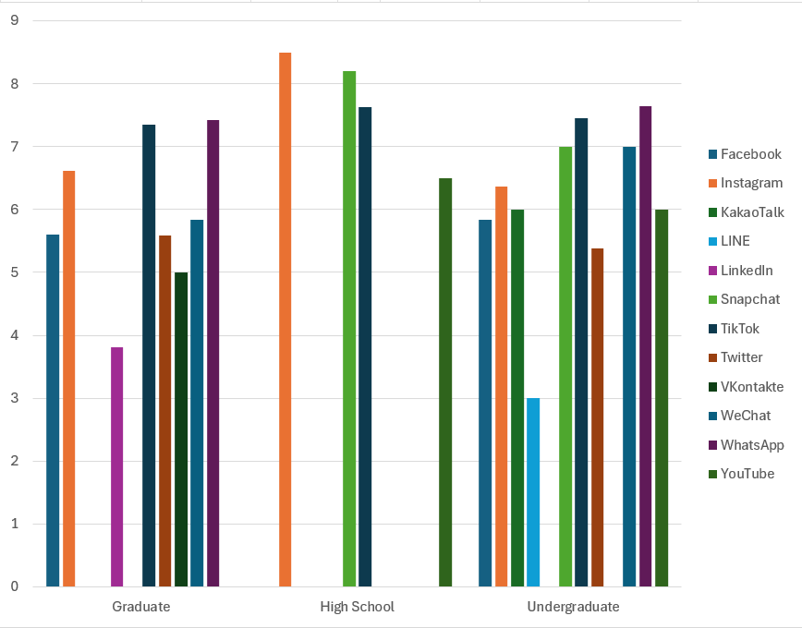

**Observations:**

* **Graduates**:
  + Heavily use **Facebook, WhatsApp, LinkedIn, and Instagram**.
  + Moderate use of Twitter and YouTube.
  + Low use of LINE.
  + More professional platforms (e.g., LinkedIn) are relatively stronger in this group.
* **High School students**:
  + Extremely high use of **Instagram (≈8.5)** and **KakaoTalk (≈8.2)**.
  + Strong activity on **Snapchat and TikTok**.
  + Almost no usage of professional platforms like LinkedIn.
  + Their preferences are more entertainment/social oriented.
* **Undergraduates**:
  + Balanced across platforms.
  + Strong on **WhatsApp, TikTok, Facebook, and YouTube** (≈7–8).
  + Moderate Instagram and Snapchat use.
  + More diverse compared to high school students.

**. Trends:**

* **Instagram dominates among high school students**, making it the top platform for younger users.
* **Graduates prefer professional and communication-focused platforms** (LinkedIn, WhatsApp, Facebook).
* **Undergraduates show a balance** between professional platforms and entertainment apps.
* Entertainment/social apps (**Instagram, TikTok, Snapchat**) are more popular among **younger groups**, while **LinkedIn and Facebook** are stronger among **graduates**.

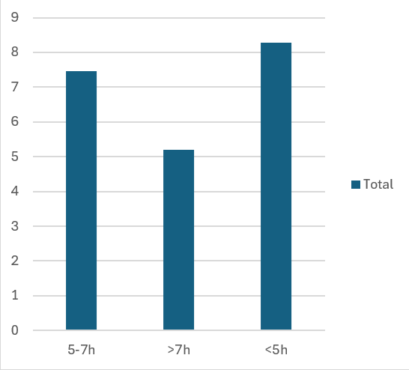8-**Average of Addicted_Score by Sleep Category.**

Most individuals are **not meeting recommended sleep guidelines**.

* This pattern may negatively affect **health, academic performance, and well-being**, and could be linked to **lifestyle factors** such as high social media usage or stress.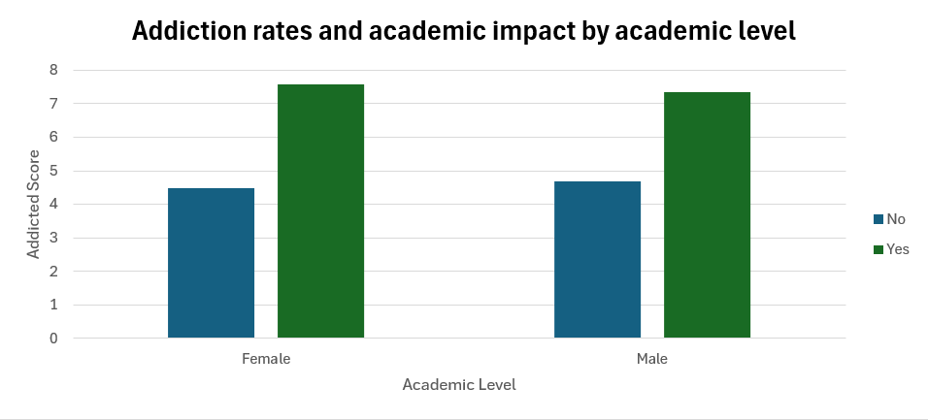

• **Female students**:

* Those who are not addicted scored around **4.5**.
* Those who are addicted scored much higher, about **7.6**.
* This indicates a significant difference in addiction impact on females.

• **Male students**:

* Non-addicted males scored about **4.7**.
* Addicted males scored around **7.3**.
* Similar to females, there is a noticeable rise in scores for addicted males.

• **Comparison between genders**:

* Both males and females follow the same pattern: addicted students score significantly higher on the addiction scale compared to non-addicted students.
* The difference between addicted and non-addicted groups is slightly larger among females (about 3.1 points) compared to males (about 2.6 points).
* Overall, addiction appears to have a **stronger academic impact on females** than on males.

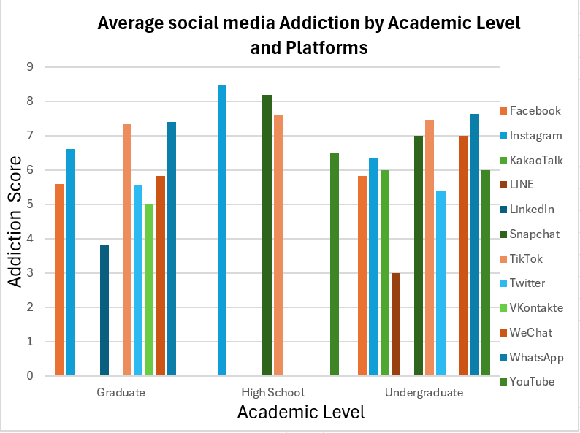

**1. Graduate students**

* The highest addiction levels are on **Instagram (~6.6)**, **TikTok (~7.3)**, **Twitter (~7.5)**, and **WhatsApp (~8.5)**.
* Moderate use is seen on **Facebook (~5.6)** and **YouTube (~5.8)**.
* The lowest score appears with **LinkedIn (~3.8)**, which makes sense since it is more career-focused.

**2. High School students**

* High schoolers show **very high addiction scores**, especially on **WhatsApp (~8.5)**, **KakaoTalk (~8.2)**, and **TikTok (~7.6)**.
* This indicates that younger students are more addicted to **instant messaging and entertainment-based apps**.

**3. Undergraduate students**

* Addiction levels are more balanced across platforms.
* High scores appear on **Instagram (~6.3)**, **TikTok (~7.4)**, **WhatsApp (~7.6)**, and **YouTube (~6.0)**.
* Less engagement is observed with **LINE (~3.0)** and **LinkedIn (~5.4)**.

**4. General observations**

* **WhatsApp and TikTok** are the most addictive platforms across all levels.
* **High school students** show the **highest overall addiction**, especially to chat-based apps.
* **Graduates** lean more towards professional and general communication apps but still show high engagement with Twitter and WhatsApp.
* 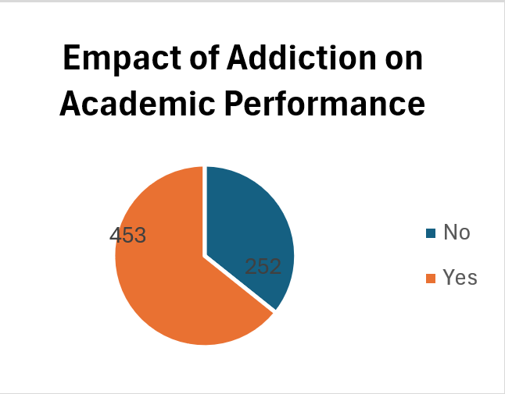**Undergraduates** show moderate to high addiction across many platforms, indicating diverse use
* The data clearly indicates that **addiction has a significant negative effect on academics**, with nearly **two-thirds of students (around 64%)** admitting that their performance is impacted. Only about **36%** reported no effect.
* 👉 In conclusion, the chart suggests that **academic performance is strongly influenced by addiction**, with the majority of students experiencing a decline due to addictive behaviors.

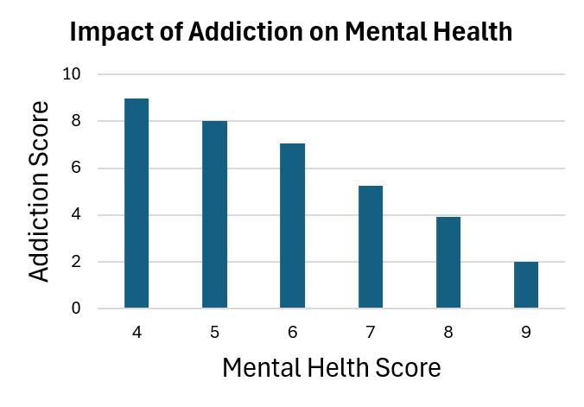• **Low mental health scores (4–6):**

* Students with poor mental health (score 4) have the **highest addiction score (~9)**.
* As mental health scores increase slightly (5–6), addiction levels drop but still remain high (~7–8).
* This suggests that weaker mental health is strongly linked to higher addiction.

• **Moderate mental health scores (7):**

* Addiction scores decrease to around **5**, showing a noticeable decline compared to lower mental health levels.

• **High mental health scores (8–9):**

* Students with stronger mental health report **very low addiction levels (4 → 2)**.
* This indicates that good mental health may act as a protective factor against addiction.

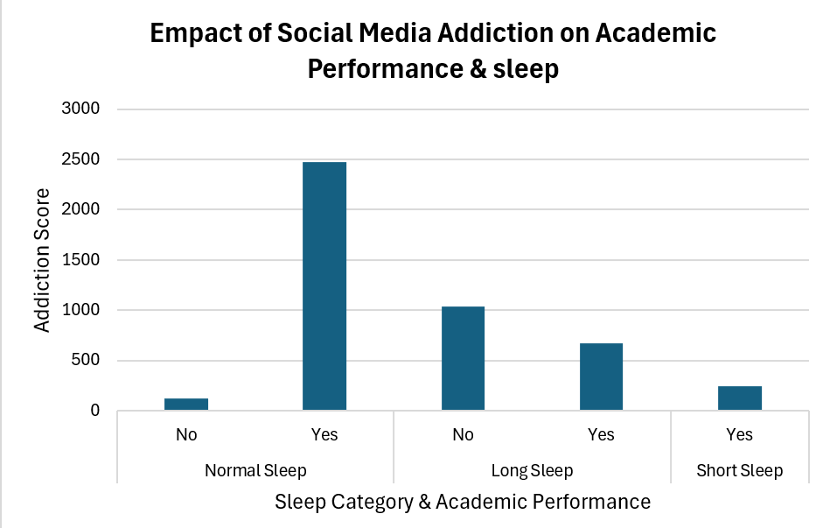• **Normal Sleep**

* Students with normal sleep but **no addiction** have very low scores (~100).
* Those with normal sleep but **addiction** show extremely high scores (~2500).
* This suggests that even with good sleep patterns, addiction strongly affects academic performance.

• **Long Sleep**

* Non-addicted students score around **1000**, which is higher than the normal-sleep non-addicted group.
* Addicted students with long sleep score about **650**, showing a reduction compared to normal sleep addicted students.
* This may suggest that excessive sleep reduces the effect of addiction but still does not eliminate it.

• **Short Sleep**

* Only addicted students are shown here, with a score of about **220**.
* This is the lowest among addicted groups, possibly because short sleep limits time spent on social media but may still harm academic performance.

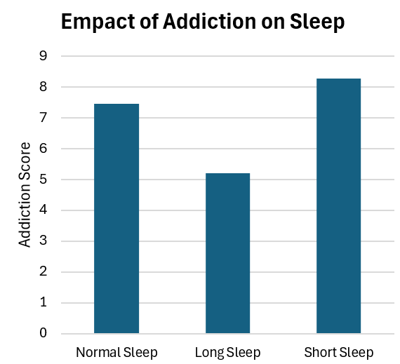

The chart shows a clear relationship between **sleep patterns and addiction**:

* **Short sleep** is strongly associated with the **highest addiction**.
* **Long sleep** seems to protect against addiction, showing the lowest score.
* **Normal sleep** still has significant addiction levels, though lower than short sleep.

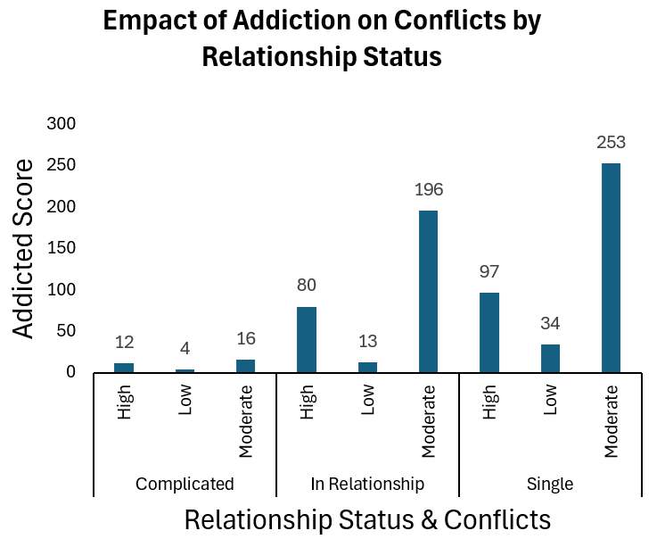• **Complicated relationships**

* Addiction scores are relatively low across all conflict levels: **High (12)**, **Low (4)**, and **Moderate (16)**.
* This suggests that people in complicated relationships show less addiction-related conflict compared to other groups.

• **In a relationship**

* **High conflict:** Addiction score is **80**, showing a noticeable impact.
* **Low conflict:** Score is much smaller (**13**).
* **Moderate conflict:** Very high score (**196**), showing that moderate conflicts in relationships are strongly linked to addiction.

• **Single individuals**

* **High conflict:** Score is **97**, higher than those in a relationship with high conflict.
* **Low conflict:** Score is **34**, higher than the low-conflict group in relationships.
* **Moderate conflict:** The highest overall score (**253**), indicating that singles with moderate conflicts experience the strongest addiction impact.

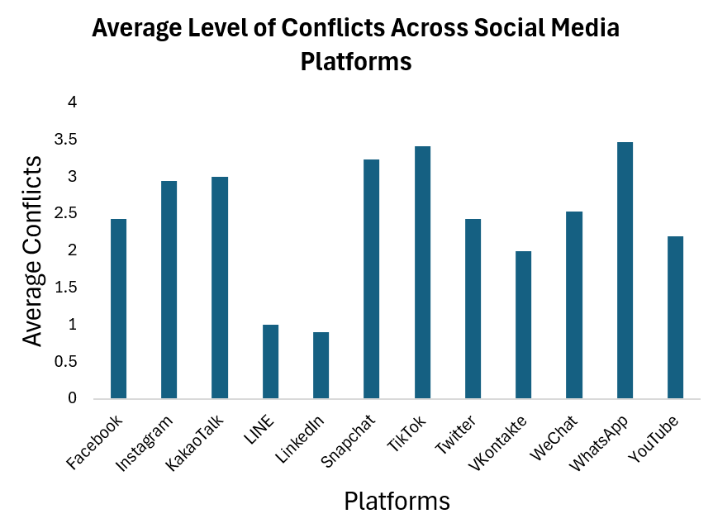• **Highest conflict levels**

* **WhatsApp (~3.5)** and **TikTok (~3.4)** show the highest average conflict levels.
* **Snapchat (~3.2)** also records a high level of conflicts.
* These platforms are heavily communication- and entertainment-based, which may explain their link to higher conflicts.

• **Moderately high conflict levels**

* **KakaoTalk (~3.0)**, **Instagram (~2.9)**, and **WeChat (~2.5)** show moderate to high conflicts.
* **Facebook (~2.4)** and **Twitter (~2.4)** also fall into this range, reflecting their wide use in social interactions and discussions.

• **Lower conflict levels**

* **YouTube (~2.2)** and **VK (~2.0)** show relatively low conflict levels.
* 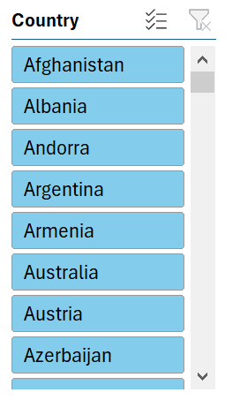**LINE (~1.0)** and **LinkedIn (~0.9)** record the lowest conflicts, likely because they are less focused on personal interactions or entertainment.

This list represents a **country selection**, arranged alphabetically, with options to sort, filter, and scroll through. It is likely part of a data dashboard or interface designed to let users focus on specific countries for analysis.

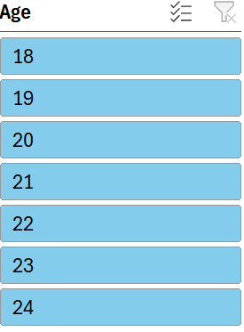This list represents an **age-based filter (18–24 years old)**, useful for focusing on data related to young adults. It likely helps in analyzing patterns such as **addiction, social media usage, or academic performance** within this age group.

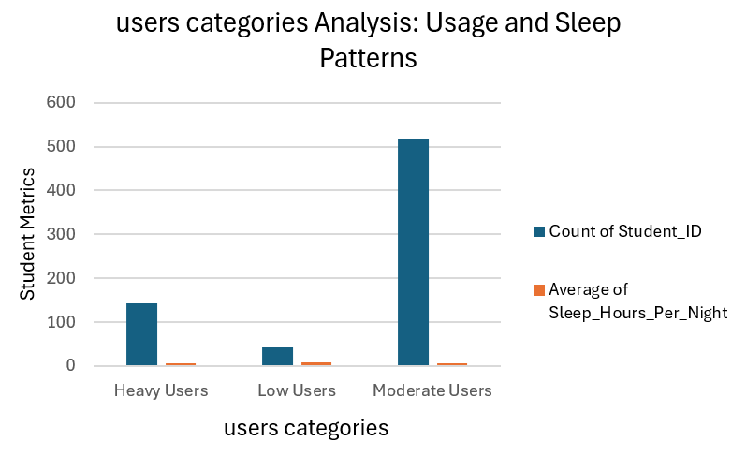The data suggests that **higher social media usage reduces sleep quality and duration**. While **Low Users** enjoy the most rest, **Heavy Users** risk sleep deprivation. This highlights the **potential health and academic**

**impacts** of excessive social media use.

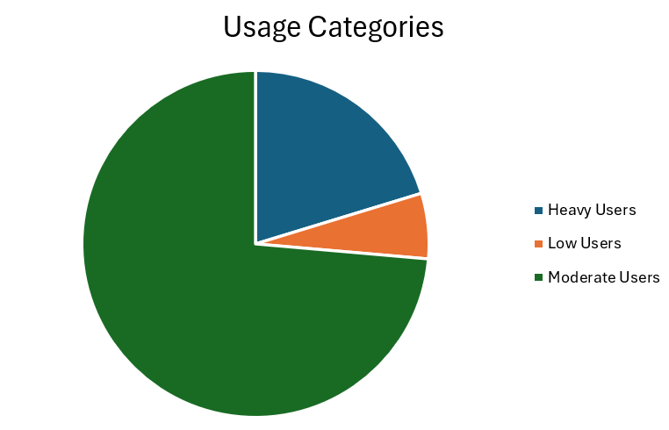The chart reveals that **most students are moderate users**, while a considerable minority fall into **heavy usage**, raising concerns about their well-being. **Low users are rare**, suggesting that minimizing social media consumption is less common among students.

The chart highlights a **serious concern**, as the majority of users fall into the **high or moderate addiction categories**, while **low addiction levels are rare**. This implies that **digital addiction is a widespread issue**, potentially impacting mental health, relationships, and daily functioning.